Point breakdown:

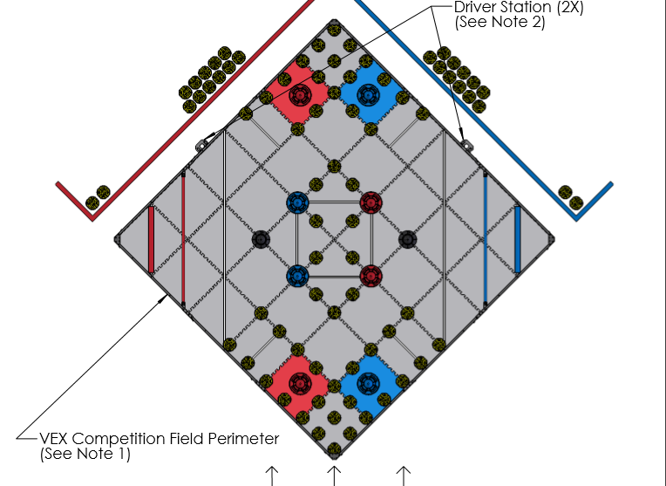

Point Breakdown

# Max points in equal division

**Max points when field cones are split between two teams**

**Autonomous:** 10pt

**Win:** 10

**Cones:** 160pt

**On field: (**26*2) * (2)

**Preload: (**2*2) * (2)

**Driver Load: (**12*2) * (2)

**Mobile goals:** 50pt

**20pt Zone:** 1*(20)

**10pt Zone:** 3* (10)

**Highest stack:** 15pt

**20pt Zone:** 5

**10pt Zone:** 5

**Stationary Goal:** 5

**Park Bonus**: 4pt

**Team square:** 2*(2)

***Total:*** *239*

# Max possible points

**Theoretical – due to opposition this is impossible.**

**Autonomous:** 10pt

**Win:** 10

**Cones:** 80pt

**On Field:** 26 * (2)

**Preload**: 2 * (2)

**Driver load:** 12 * (2)

**Mobile goals:** 50pt

**20pt Zone:** 1*(20)

**10pt Zone:** 3* (10)

**Highest stack:** 15pt

**20pt Zone:** 5

**10pt Zone:** 5

**Stationary Goal:** 5

**Park Bonus**: 4pt

**Team square:** 2*(2)

***Total:*** *159*

**Note:** It is not worth the effort of putting a Mobile Goal in the 5pt zone as assuming you get highest stack in the 5pt zone 50% of the time it is only worth 7.5 points compared to putting in the 10-point stack where it is always worth 10 points.

## Target: 159pt

By looking at the high score breakdown we have decided our score target for the end of the season is 159pt

|  |  |  |  |  |  |  |
| --- | --- | --- | --- | --- | --- | --- |
| **Category** | **Name** | **Individual points** | **Amount** | **Overall points** | **Percentage** | **Difficulty** |
| Autonomous | Win | 10 | 1 | 10 | 06.29% |  |
| Cones | On Field | 2 | 26 | 52 | 32.70% |  |
| Preload | 2 | 2 | 4 | 02.52% |  |
| Driver Load | 2 | 12 | 24 | 15.09% |  |
| Mobile Goal | 20pt Zone | 20 | 1 | 20 | 12.58% |  |
| 10pt Zone | 10 | 3 | 30 | 18.87% |  |
| Highest Stack | 20pt Zone | 5 | 1 | 5 | 03.14% |  |
| 10pt Zone | 5 | 1 | 5 | 03.14% |  |
| Static Goal | 5 | 1 | 5 | 03.14% |  |
| Park Bonus | Team square | 2 | 2 | 4 | 02.52% |  |
| **Total** | **Everything** |  |  | **159** | **100%** |  |
| Autonomous | Total | 10 | 1 | 10 | 06.29% |  |
| Cones | Total | 2 | 40 | 80 | 50.31% |  |
| Mobile Goal | Total |  |  | 50 | 31.45% |  |
| Highest Stack | Total | 5 | 3 | 15 | 09.43% |  |
| Park Bonus | Total | 2 | 2 | 4 | 02.52% |  |

Looking at the statistics above we can see scoring mobiles goals is the easiest way to score a high amount of points. Being relatively easy to score and making up 31.45% of the average max points, scoring cones is an easy way to gain lots of points early in the round. Because of this we think that we will see a lot of robots focusing on just scoring the mobile goals in the first quarter of the season before the main robot design meta emerges. The parking bonus is also easy to get, however since it is only equal to 2.52% of points it is negligible. The autonomous bonus and highest stack bonus are dependent on the skill level of the opposite team and have no static difficulty. Lastly, we come to cones. these are the highest way to score points however in our opinion they are also the hardest. We think that the scoring of cones in the beginning of the season will not as important but as time passes and robots improve it will become more of an significant factor in scoring.

# Analysis